Application Form

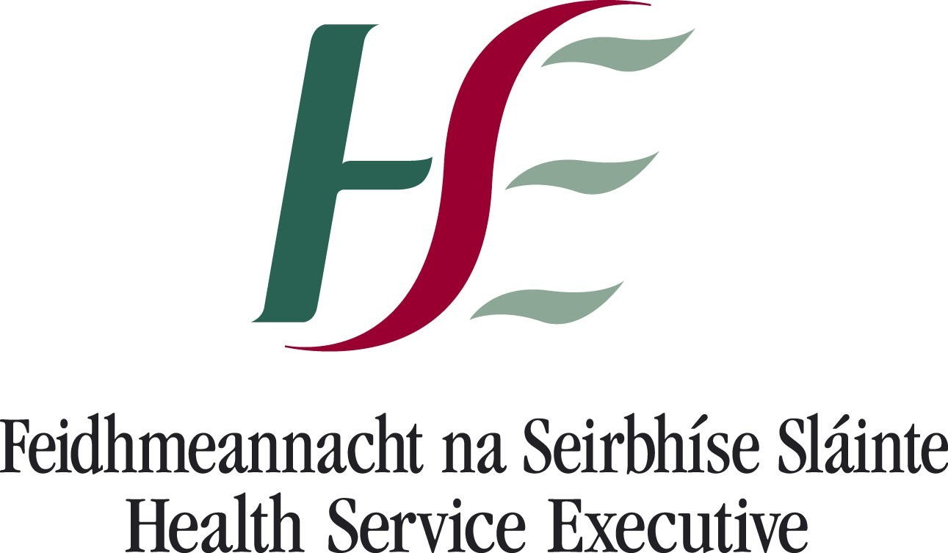

Section 38 / Section 39
Health Act, 2004

Application Form

This form should be submitted by voluntary/non-statutory agencies when applying for funding from the HSE

An electronic version of this form is available for completion

Application to Health Service Executive For Funding to Non-Statutory Agencies

Organisational Details

Name of Organisation |  | The Men’s Health Forum in Ireland

Address of Organisation
Registered Company Address:
c/o Paula Carroll
Department of Health, Sport and Exercise Science
Waterford Institute of Technology
Cork Road
Waterford

Telephone Number |  |  |  |  | 0044 2871 377777
Fax Number |  |  |  |  | Not Applicable
Contact e-mail |  |  |  |  | secretary@mhfi.org
Website |  |  |  |  | www.mhfi.org
Name & Address of Chairperson
Noel Richardson
Centre for Men’s Health
Institute of Technology Carlow
Kilkenny Road
Carlow

Name & Address of Secretary of Board
Paula Carroll
Department of Health, Sport and Exercise Science
Waterford Institute of Technology
Cork Road
Waterford

Name & Address of Treasurer
Mary Sheehan
Flexible Training Unit
Unit 6, Brookfield Enterprise Centre
Brookfield
Dublin 24

Name & Address of Main Contact/Liaison Person
Paula Carroll
Department of Health, Sport and Exercise Science
Waterford Institute of Technology
Cork Road
Waterford
Email: PCarroll@wit.ie
Status of Organisation
Registered Charity | Tick  ✓ |  |  | Limited Company |  |  | Tick  ✓ |  | Other |  | Tick
Charity (CHY) No. |  |  | XR83376 |  |  | Company Ref. |  |  |  | NI054325
Tax Clearance Cert. No. |  |  | Not Applicable |  |  |  |  | Expiry Date |  | Not Applicable

History & Background of Organisation

When was organisation established? | Year 2002
Does the organisation have formal Constitutional Documents e.g. Articles of Association? | Tick ✓
Please outline your organisational structure by diagram

The Men's Health Forum in Ireland (MHFI) is a charitable organisation promoting all aspects of the health and well being of men and boys on the island of Ireland through research, education, health initiatives, campaigning and advocacy.

MHFI recognises the right of all men to good health regardless of age, gender, sexual orientation, disability, race, culture, religious or political affiliations.

MHFI believes that men have the right to:

- the best possible health, irrespective of social, cultural, political or ethnic differences;
- gender-specific information and education initiatives on how to keep themselves healthy;
- equity of access to available, affordable and gender-sensitive services for all men;
- have their issues recognised and properly addressed - in a way that is not at the expense of women’s or children’s health, but seen as beneficial to society as a whole;
- call for greater emphasis on a partnership approach in developing future strategies or initiatives on men’s health. This includes consultation between policy-makers, health-care providers, statutory and voluntary groups working on behalf of men, employers, and men themselves.

MHFI is, currently, governed by a Board of Trustees/Directors (with seven members). This Board has also established a Steering Committee - comprised of Trustees and other relevant agencies in this field - which advises on the focus, nature and practicalities of the work which is undertaken. Anyone who can agree with the aims and value base of MHFI can register to be part of the Forum’s mailing database, and to receive regular newsletters and updates on work in this area. They can also circulate information about their own work and activities to others on the database.

Where funding is over €50,000 the completion of governance Self evaluation questionnaire is required.
Identify Specific Target Groups of your Organisation (Please tick not more than three)

Older Persons |  | Disability Intellectual |  | Disability Physical and Sensory
Young People |  | Families |  | Women
Men | ✓ | Carers |  | Travellers
Social exclusion | ✓ | Homeless |  | Lone Parents
Mental Health | ✓ | Children at Risk |  | Children 0-6 years
Substance misuse |  | Other (please specify)

Other relevant information
The principal activity for which MHFI utilises HSE funding is to coordinate Men’s Health Week. For a copy of the Men’s Health Week 2009 Evaluation Report, see: www.mhfi.org/mhwevaluation2009.pdf

(Please attach your Access/Admissions Discharge Policy if available)

Describe the activities of your Organisation (Please tick not more than three)

Advocacy | ✓ | Community activities | ✓ | Social activities
Research | ✓ | Counselling/Support |  | Information/Advice
Housing |  | Self Help |  | Training
Health care services |  | Other (Please specify)

Other relevant information
For a copy of the 2009 Annual Report, which sets out the key activities of MHFI in 2009, see www.mhfi.org/agmreport2009.pdf

Indicate the geographical catchment area covered
MHFI works on an all-island basis.
List Aims and Objectives of the Organisation referring to Articles of Association where applicable

The Forum’s Objects are:
- the advancement of the education of the general public in all matters relating to men’s health and in particular, but not exclusively, by providing information, commissioning and disseminating research, and providing education on men’s health and associated issues to health professionals and the general public;
- the preservation and protection of men’s health.

Staffing of Organisation

Please give details of current numbers of paid, voluntary, community employment, and other workers involved in your Organisation

Paid Full Time | Paid Part Time | Volunteers | CE/ Supported Employment Schemes | Other | Total
 | 1 | 9

Service / Project Description

Outline the service/project for which the funding is being sought.

 | Yes | No
Is this application to support a new service?
If this application is to support a new service is it once off?
If this is an existing service has it been previously funded by the HSE? | ✓
If the Project is once off please provide commencement and end dates.
Commencement Date: NOT APPLICABLE
End Date:

If this is an existing service not previously funded by the HSE, please provide details of previous funding source, and provide an explanation for cessation of funding.

NOT APPLICABLE

List in order of importance the services/activities to be provided
(use separate sheet if necessary)

Service/Activity | Nos. availing | Frequency | Charge for service

Total No of individuals benefiting

Grant Total

Aged under 6 yrs | Aged 6 to 12 yrs | Aged 13 to 18yrs | Aged 19-65 yrs | Aged 65yrs +

Other relevant information.

Describe the identified need your organisation is seeking to satisfy. Please provide relevant information to support application
The Men’s Health Forum in Ireland (MHFI) was established in response to the growing recognition of the need to address the poor health of males in Ireland. MHFI is a voluntary network of individuals and organisations, men and women, which seeks to promote all aspects of the health and well being of men and boys through research, education, health initiatives, training, campaigning and advocacy.

This need was clearly, and succinctly, outlined in the Foreword to the National Men’s Health Policy 2008-2013: “The case for an increased focus on men’s health is compelling. Men die, on average, almost five years younger than women do and have higher death rates at all ages, and for all leading causes of death. The burden of ill-health and premature mortality is borne, in particular, by men from the lower socio-economic groups. There has been a disturbing increase in suicide rates among men in recent years, with suicide among young men being particularly high. Despite traditionally being to the forefront of health service policy and provision, men have tended to be more reticent in terms of advocating or speaking out about their own health … Targeting men’s health can impact not just on men’s lives, but can have positive spin-offs for the lives of women and children”.

Describe how you propose to address the identified need
The Men’s Health Forum in Ireland is seeking support to join with other countries across Europe, and further afield, to mark International Men’s Health Week 2011. This will take place from 13th - 19th June 2011 (although the theme for 2011 has still to be agreed with our international partners).

Men’s Health Week (MHW) provides a unique opportunity for everyone (health professionals, service providers, sporting bodies, community groups, employers, policy makers, the media, individuals ...) to encourage men and boys to take better care of their health and to seek help or treatment at an early stage.

Aim
To co-ordinate a range of initiatives in partnership with key stakeholders, that will focus on the theme of International Men’s Health Week 13th – 19th June 2011 (theme as yet undefined)

Background
It is proposed that the Men’s Health Forum in Ireland (MHFI) will take the lead role on this project. Over the past four years, MHFI, with the aid of funding from the HSE, has co-ordinated a range of activities to coincide with Men’s Health Week. These have included; a health screening and health promotion campaign at the National Ploughing Championships (2005), a national conference on men and mental health (2006), a public relations campaign on men and chronic health conditions (2007); working in partnership with key stakeholders in the workplace and distributing 5000 min-manuals on workplace men’s health issues (2008); and co-ordinating a national poster campaign (distributed to all GP practices, bookies offices and golf clubs) focusing on the key message ‘Don’t wait til it’s too late’ (men and services); and working with RTE’s Nationwide on a 10 minute television piece for men’s health week on the same theme (2009). As outlined above, preparations are at an advanced stage for Men’s Health Week 2010. With its well-established role in men’s health advocacy work, MHFI is well placed to be the lead agent in this project.

Development of Work Plan for Men’s Health Week
- Planning and development of work plan for Men’s Health Week, to include liaison and partnership working with key stakeholders, including, among others, the HSE, ICGP, NGOs and the private sector, on relevant issues that coincide with the theme of men’s health week
- Liaison with the HSE and the UK Men’s Health Forum on the design and publication of appropriate health information literature for Men’s Health Week 2008

Co-ordination of Men’s Health Week
- Development of a glossary of all men’s health events being undertaken during and around Men’s Health Week
- Providing support, where appropriate, to key stakeholders in the delivery of men’s health initiatives during Men’s Health Week (e.g. co-ordinating the delivery of health information literature to primary care settings, liaising with the press in the promotion of the event, making MHFI members available as guest speakers)
- Co-ordinating press release and media campaign promoting relevant aspects of the chosen theme for men’s health week

Evaluation of Men’s Health Week
- Documentation and profiling of number and nature of events organised
- Collation of evaluation reports from specific men’s health initiatives
- Audit of coverage received in local and national press
- Assessment of impact of initiatives undertaken

Key Deliverables:
- The development of a detailed work plan or glossary for Men’s Health Week arising from consultation and partnership working with key stakeholders, and that clearly documents a range of initiatives to coincide with Men’s Health Week. The work plan/glossary should include details of (i) the nature and scope of the event (ii) the key methodologies being used (iii) the target group (iv) the lead agent(s) (and contact details) tasked with delivering the initiative (v) the means to evaluate the initiative
- The design and publication of appropriate and supportive men’s health information literature, for dissemination in different health service settings during Men’s Health Week
- Audit and evaluation of the outcomes of Men’s Health Week

Timeframe

Aug/Dec 2010 | Development of work plan; preparatory liaison work with key stakeholders, so that their work plans for 2010 can take account of and provisionally plan for Men’s Health Week 2010
Jan- May 2011 | Partnership work with key stakeholders on the development of key men’s health initiatives  Liaison with HSE and UK Men’s Health Forum on the design and publication of appropriate and supportive men’s health information literature, for dissemination in health service settings during Men’s Health Week  Development and dissemination of press release and media campaign highlighting key themes for Men’s Health Week
13-19 Jun 2011 | Men’s Health Week
Aug 2011 | Completion of audit and evaluation report of Men’s Health Week

Costings: €15,000

Outline the expected benefits/outcomes of the service/project
MHW provides a national focus for highlighting the health needs of men and boys, and seeks to …

- Heighten awareness of preventable health problems for males of all ages.
- Support men and boys to engage in healthier lifestyle choices / activities.
- Encourage the early detection and treatment of health difficulties in males.

This is achieved through a mix of: targeted and intensive media coverage; support for, local projects who wish to organise health-related initiatives for males, and the promotion of these activities; a national campaign with a strong key message; encouraging national bodies to contribute to the theme.

An evaluation of work undertaken is also conducted.

Outline how the service/project will integrate with other agencies and organisations
Each year MHFI works in partnership with a range of other organisations to celebrate MHW. For example, during 2010 (which has the theme “Men and Physical Activity”) these partners include staff from the GAA, FAI, IFA, IRFU, Irish Cancer Society, Irish Heart Foundation, Sport NI, Irish Sports Council, Men’s Development Network, Public Health Agency, Healthy Cities Project, Ulster Cancer Foundation, Sure Start Fathers Network, British Medical Association NI, Man Matters Project, Belfast Community Sports Development Network, Health Service Executive and the Marie Keating Foundation.

All of these groups have given a commitment to promote MHW in their own workplaces and with their own constituents, as well as to organise a broad range of activities to mark this occasion. The national sporting bodies have asked MHFI to provide men’s health training to their staff, so that knowledge and information can be cascaded more widely within each body. All of the partners will also contribute to a large-scale event which will be held in the Phoenix Park, Dublin, in the middle of Men’s Health Week. This will act as the national focus for MHW.

Indicate how this Proposal represents Value for Money
This proposal will draw heavily upon the voluntary input (time, resources, facilities, contacts, skills…) of a vast range of organisations throughout Ireland. The money provided will be used to: solicit interest from national and local groups; maintain a working partnership between the lead agencies; kick start on-the-ground projects; ensure that awareness of men’s health issues is raised via local and national media. This financial support will also enable MHFI to generate further funding to underwrite the cost of practical initiatives across the country. Thus, as ‘seed funding’, it will have a ‘snowball’ effect, and will provide excellent value for money.

Funding Requirements

Has your Organisation previously applied for funding for this or a similar project from the HSE or another public source? If yes, please set out details  The HSE has provided financial support to MHFI to co-ordinate Men’s Health Week for the past three years |  |  | Tick  √
Has your Organisation previously applied for funding for this or a similar project from private sources? If yes, please set out details.  Eli Lilly provided financial support with the design, printing and dissemination of the poster campaign for Men’s Health Week 2010 |  |  | Tick  √
Total Amount of Funding Sought from the HSE  Details to be set out in the attached Projected Financial Summary for this Application |  | €15,000
Bank Account Details
Name of Bank: | Allied Irish Bank
Address of Bank: | 1 Main Street, Lucan, Co Dublin
Name on Bank Account: | The Men's Health Forum in Ireland
Bank Account Number: | 4406098
Bank Sort Code: | 933562
Bank Balance as of 09 / 04 / 2010 | €16,600
Any comments on account balance
Please Attach the following:
- Latest Annual Accounts prepared in accordance with Irish statutory requirements. Audited Accounts must be submitted by Organisations with a yearly total income or total expenditure of over €150,000.
- Annual Report
- Completed Projected Financial Summary for this Application on page 5 below.
- Completed Governance Self Evaluation Questionnaire if funding is over 50,000

Signed on Behalf of Organisation

Chairperson | Treasurer
Name Noel Richardson | Name Mary Sheehan
Signed 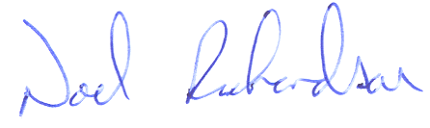 | Signed
Date 30th March 2010 | Date 30th March 2010

Appendix
Projected Financial Summary for this Application
To be completed by all organisations, whether seeking once-off or on-going funding and with a separate summary in respect of each application
Category | Once Off  € | Current Year  € | Full Year  €
Income
Income from HSE |  | €15,000
Income from Other State Agencies Please list separately

Fundraising
Client Income
Please provide description

Other Income
Please provide description

Total Income |  | €15,000
Expenditure
Salaries (incl. PRSI) |  | €12,500
Bank Charges |  | €200
Telephone |  | €500
Postage |  | €400
Rent
Heat & Light
Insurance |  | €700
Training |  | €600
Other Expenses |  | €300
Total Expenditure |  | €15,000
Surplus / (Deficit)
Comments

Checklist | Yes | No | N/A
* N/A Blacked out indicates that the requirement is mandatory | Tick | Tick | Tick*
Fully Completed Application Form | √
Charitable Status Number or Tax Clearance Certificate  (if grant is over €10,000) | √
Insurance  If the amount of funding sought from HSE is over €250,000, please confirm that the Organisation be in a position to comply with the HSE requirements for insurance contained in the Service Arrangement – Section 14 and Schedule 7 as follows:  Public Liability Insurance with a limit of indemnity of €6.4m (any one occurrence) to the HSE  Employer’s Liability Insurance with a limit of indemnity of €12.7m (any one occurrence) to the HSE  Motor Insurance (if service involves use of motor vehicles) with a third party property damage limit of €2.6m (any one occurrence) with an indemnity to the HSE  Professional Indemnity (if professional services are provided) with a limit of indemnity for any one occurrence of:  Low Risk - €2.6m  Medium Risk - €4.0 m  High Risk - €6.4m  If the amount of funding sought from HSE is below €250,000, please confirm that the Organisation will be in a position to comply with the HSE requirements for insurance contained in Section 3.5 of the Grant Aid Agreement as follows:  The Organisation undertakes to have sufficient insurance coverage in respect of all services or activities it delivers when using the Grant. The extent and adequacy of the insurance cover is a matter for the Organisation and its insurance advisors. |  |  | √
External Auditors Management Letter of Previous Year  Mandatory in organisations with annual income or expenditure over €150,000 |  |  | √
Annual Accounts of Previous Year  Audited Accounts must be submitted by Organisations with a yearly total income or total expenditure of over €150,000 | √
Service Activity Report for Previous Year | √
Completed Projected Financial Summary for this Application | √
Access Admission Discharge policy |  |  | √
Annual Report – Most Recent Year | √
Checklist for Application

This checklist must accompany all applications. Please ensure that all information required above has been furnished and that the documents below are enclosed to ensure that applications are processed as quickly as possible

